**Java SE Course - Practice assignments:**

Implement a Java class which provides the following utilities to a character array:

* Reverse an array elements:

Example: [‘a’,’b’,’c’] shall be changed to [‘c’,’b’,’a’]

* Change the characters case to the upper case

Example: [‘m’,’H’,’a’,’m’,’m’,’A’,’D’] shall be changed to [‘M’,’H’,’A’,’M’,’M,’A’,’D’]

* Change the characters case to the lower case

Example: [‘m’,’H’,’a’,’m’,’m’,’A’,’D’] shall be changed to [‘m’,’h’,’a’,’m’,’m’,’a’,’d’]

* Toggle the case of the characters in the array

Example: [‘m’,’H’,’a’,’m’,’m’,’A’,’D’] shall be changed to [‘M’,’h’,’A’,’M’,’M,’a’,’d’]

* Get a copy from an array:

Example: take a copy from [‘c’,’o’,’p’,’y’] starting from index 1 copying 2 elements shall result to [‘o’,’p’]

* Get an extended copy of an array: create a new extended copy of an array which contains the same contents with extra ***n*** elements, for example: you need to get a copy of [‘a’,’b’,’c’] with extra 3 empty (or a specified value) elements shall result with [‘a’,’b’,’c’,’ ‘,’ ‘, ‘ ‘]

Implement a Java class which provides the following utilities to an integer array:

* Sorting for array elements.
  + Insertion sort
* Searching for an element in array:
  + Linear search.
  + Binary search.

Implement a Java class that supports Mathematical Matrix operations (two dimensional arrays):

* Sum of two arrays: It shall accept two instances of dimensional arrays that has the same size (columns and rows numbers) then returns the sum of both arrays in a new array, example:



* Scalar Multiplication: multiply a matrix with a number, the number will be multiplied with each element in the matrix, example below:



* Transportation: produce a new matrix from another matrix by changing each tow in the matrix to a column.

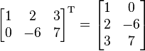

* Matrix Multiplication: Multiplication of two matrices is defined if and only if the number of columns of the left matrix is the same as the number of rows of the right matrix.

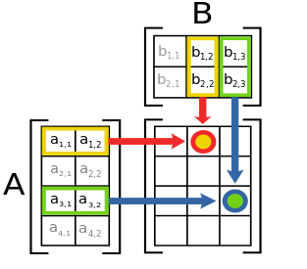

* Submatrix: A submatrix of a matrix is obtained by deleting any collection of rows and/or columns.For example, from the following 3-by-4 matrix, we can construct a 2-by-3 submatrix by removing row 3 and column 2:

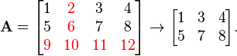

* Square Matrix operations: Those operations are made to a square matrix where number of columns is equal to the number of rows. Square matrix operations are aimed to zero a matrix elements according to the following:
  + Change Matrix to a diagonal matrix: all elements values are set to zero except the elements in the diagonal

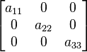

* + Change matrix to a lower triangular matrix: all values on top of the diagonal are set to 0.

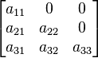

* + Change matrix to a upper triangular matrix: all values on bottom of the diagonal are set to 0.

